WEEK – 1

Implementing the library management system

Nipuna Amanapu

superset id : 6432842

**Exercise 6: Library Management System**

**Scenario:**

You are developing a library management system where users can search for books by title or author.

**Steps:**

1. **Understand Search Algorithms:**
   * Explain linear search and binary search algorithms.
2. **Setup:**
   * Create a class **Book** with attributes like **bookId**, **title**, and **author**.
3. **Implementation:**
   * Implement linear search to find books by title.
   * Implement binary search to find books by title (assuming the list is sorted).
4. **Analysis:**
   * Compare the time complexity of linear and binary search.
   * Discuss when to use each algorithm based on the data set size and order.

Solution:

1)LibraryManagementSystem

import java.util.*;

class Book {

    int bookId;

    String title;

    String author;

    Book(int bookId, String title, String author) {

        this.bookId = bookId;

        this.title = title;

        this.author = author;

    }

    void display() {

        System.out.println("Book ID: " + bookId + ", Title: " + title + ", Author: " + author);

    }

}

public class LibraryManagementSystem {

    public static Book linearSearchByTitle(List<Book> books, String title) {

        for (Book book : books) {

            if (book.title.equalsIgnoreCase(title)) {

                return book;

            }

        }

        return null;

    }

    public static Book binarySearchByTitle(List<Book> books, String title) {

        int low = 0;

        int high = books.size() - 1;

        while (low <= high) {

            int mid = (low + high) / 2;

            int compare = books.get(mid).title.compareToIgnoreCase(title);

            if (compare == 0) {

                return books.get(mid);

            } else if (compare < 0) {

                low = mid + 1;

            } else {

                high = mid - 1;

            }

        }

        return null;

    }

    public static void main(String[] args) {

        List<Book> books = new ArrayList<>();

        books.add(new Book(101, "The Hobbit", "J.R.R. Tolkien"));

        books.add(new Book(102, "1984", "George Orwell"));

        books.add(new Book(103, "To Kill a Mockingbird", "Harper Lee"));

        books.add(new Book(104, "Pride and Prejudice", "Jane Austen"));

        books.add(new Book(105, "The Catcher in the Rye", "J.D. Salinger"));

        Scanner scanner = new Scanner(System.in);

        System.out.println("\n--- Linear Search ---");

        System.out.print("Enter book title to search: ");

        String titleToSearch = scanner.nextLine();

        Book resultLinear = linearSearchByTitle(books, titleToSearch);

        if (resultLinear != null) {

            System.out.println("Book found (Linear Search):");

            resultLinear.display();

        } else {

            System.out.println("Book not found (Linear Search).");

        }

        books.sort(Comparator.comparing(b -> b.title.toLowerCase()));

        System.out.println("\n--- Binary Search ---");

        System.out.print("Enter book title to search: ");

        String titleToSearchBinary = scanner.nextLine();

        Book resultBinary = binarySearchByTitle(books, titleToSearchBinary);

        if (resultBinary != null) {

            System.out.println("Book found (Binary Search):");

            resultBinary.display();

        } else {

            System.out.println("Book not found (Binary Search).");

        }

        scanner.close();

    }

}

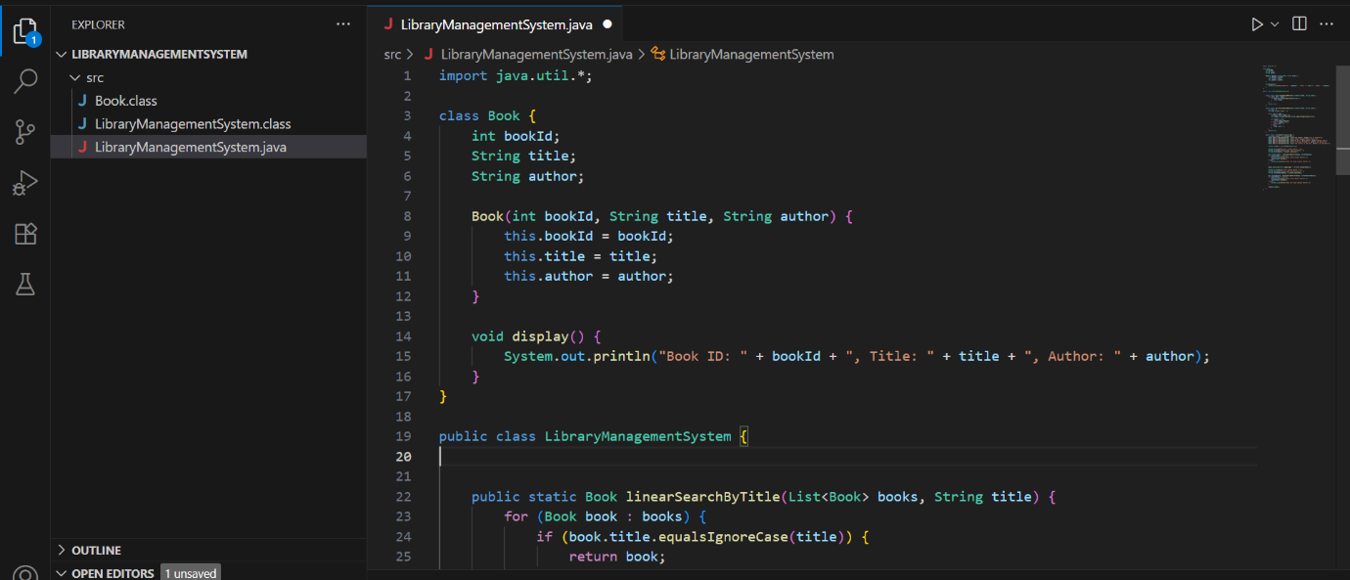

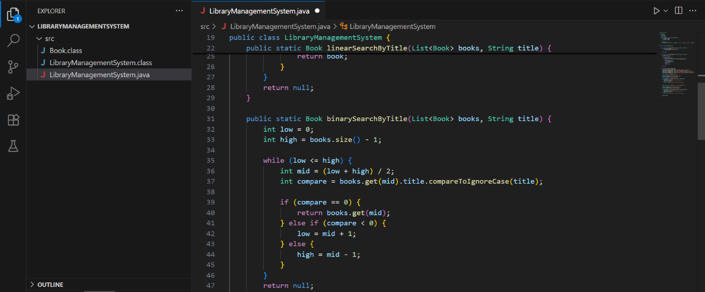

Output:

